Week2 Home Assignment #2
Build a Document Question Answering (Document QA) Agent

Develop an AI-powered Document QA agent that enables users to upload a document from their local system and ask questions based on its content. The agent should extract the document content, understand the user's query, and provide accurate answers using only the uploaded document as the source of information. If the requested information is not available in the document, the agent should respond appropriately instead of generating unsupported answers.

Expected Outcome: Users should be able to upload a document, ask multiple questions, and receive context-aware answers derived only from the uploaded document.

list of nodes :

1.Manua Trigger
2.Read /write files from disk
3.Extract from file
4.Basic LLM chain

IMPLEMENTATION DETAILS
- Added a chat trigger workflow to enable user to ask for questions.
- Added workflow for Read/Write Files from Disk and validated the step
- Added workflow Extract from File and validated the step
- Basic LLM chain – Defined the source for prompt and prompt message and also set the models
Prompt message: You are a document question-answering assistant.

Rules:
- Answer ONLY from the document below.
- Do not use outside knowledge.
- If the answer is not found, respond exactly:
"I could not find this information."

Document:
{{ $json.text }}

Question:
{{ $('When chat message received').item.json.chatInput }}

OUTPUT Screenshot with different questions
Positive flow
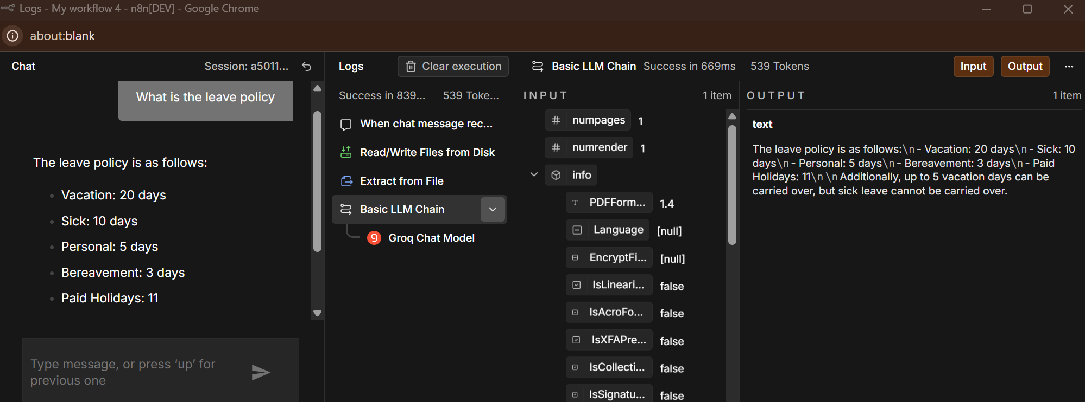
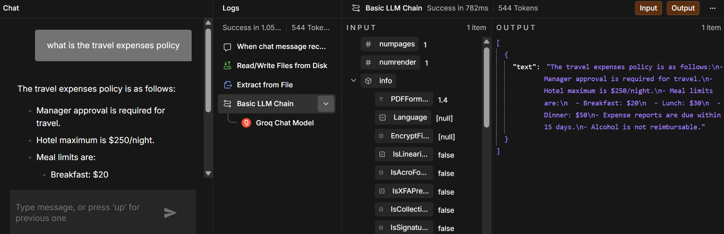
Negative flow
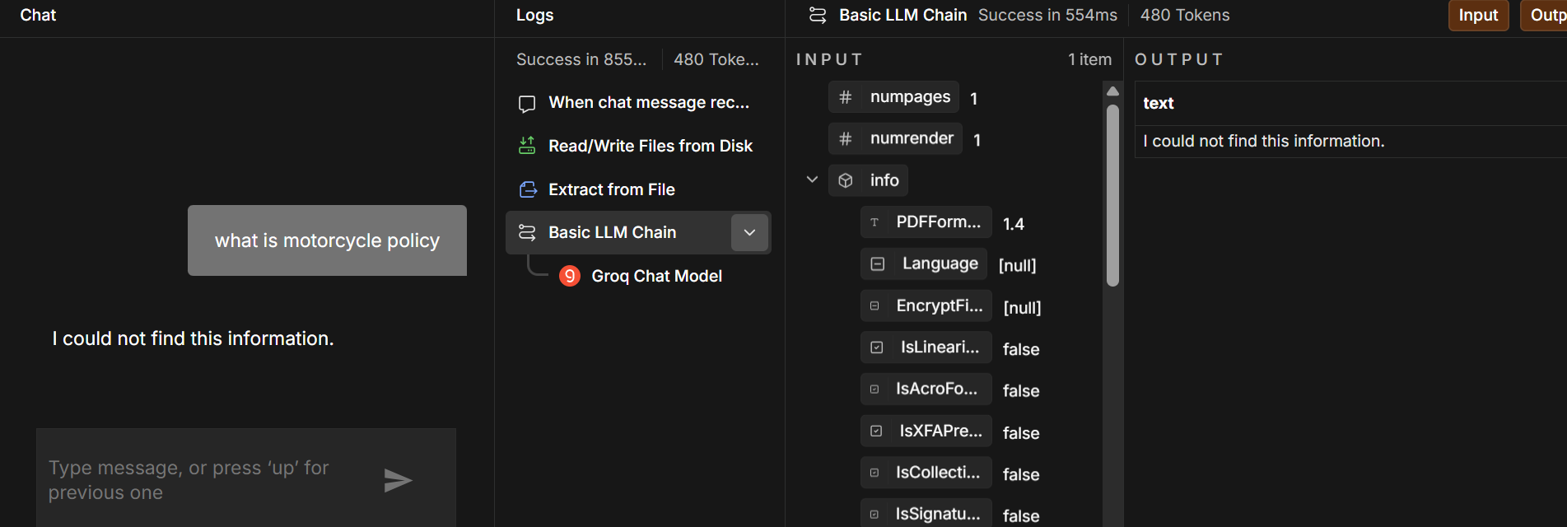

Full flow screenshot
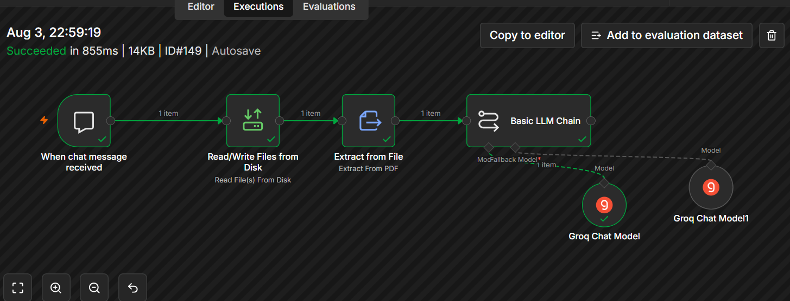

Challenges & Learnings:
- Had challenges in file access due to n8n restrictions. Explored on the ways to overcome the challenges with ChatGPTs help.
Solution: Open CMD as Administrator
Run the following 2 commands “set N8N_RESTRICT_FILE_ACCESS_TO=C:\Users\shari\OneDrive\Desktop\Srividhya\Gen AI\Phase2\day2”
“echo %N8N_RESTRICT_FILE_ACCESS_TO%”
And then npx n8n – Executed the step and validated the step output (nice learning!)
- Had challenges in Basic LLM Chain -First selected source for prompt as “Connected Chat Trigger Node” and it was auto populating the prompt message as json.chatinput and set the prompt message, however it threw error while validating the step. Then after long research with the help of Chatgpt - set as Define below and set the prompt.
- Faced challenges in Basic LLM chain after changing to Define below – the output is always asking to upload the document to look for content. Since the document path has already been given Read/write file from disk flow, spent time on analysis.
  - First model was set as a reasoning model instead of text to text model – changed to llama-3.3-70b-versatile and set the fallback model as ilama instant and it fixed the hallucination issue
  - The sample pdf document was too big with 28 pages and could not retrieve the content. So attempted with uploading a single page and it worked out.

Though completed the assignment part, shall work on understanding how to change the flow for reading content from large files. Shall explore and connect with mentors for any support if required – First hand info, the flow to be changed as following - Form Trigger | PDF Upload | PDF Extract Text | Text Splitter | Embeddings | Vector Store | Retriever | Basic LLM Chain | Answer
Overall it is a nice learning experience!

